**I used to try and "teach" code to people who wanted to learn.**

Most of the people I encountered were younger. Their parents wanted them to participate in stem programs and used the old one-liner, "if you like video games so much, how about you learn to make one." So they would come to me, and instead of making a video game, I would give them a printout of some instructions for creating a chatbox using scratch (a code building program). They would usually glance over the instructions and then ask me what to do. I would try and tell them, but so many people would be asking me the same question that I would ultimately have to redirect them to the instructions and come back around when they had a more specific question.

A lot of them would get frustrated and upset because their program was not working. Some people whose program was working would get frustrated and upset because they wanted it to do more, even though they had not completed it yet. Many of them told me that they didn't want to make a chatbot. They wanted to make a video game, and then they would ask me how to do that. I told them simply that today we were making chatbots while I tried to get them to finish their projects and save their files. Sometimes I was successful.

What I wish I would have told them was that making a video game with code, all by yourself, from scratch, with no previous experience, would be much more daunting than making a chatbot. The instructions they were following, well, some of them had been following. Those instructions were explicitly created to walk someone along a pre-determined coding path containing pre-written code hidden behind icons that you could drag and drop into place. It also featured an evident and comprehensive UI (user interface aka how we interact with computers aka the start button or the google chrome icon). Most people are used to playing video games that are in the Triple-A category. AAA games are produced and distributed by a mid-sized or major publisher, and they have higher development and marketing budgets than other game tiers. That means they usually have hundreds of very knowledgeable and qualified people, broken into smaller teams that work on specific, smaller parts of the game. Even with all those highly skilled people working together, it still can take a year or more to create that game.

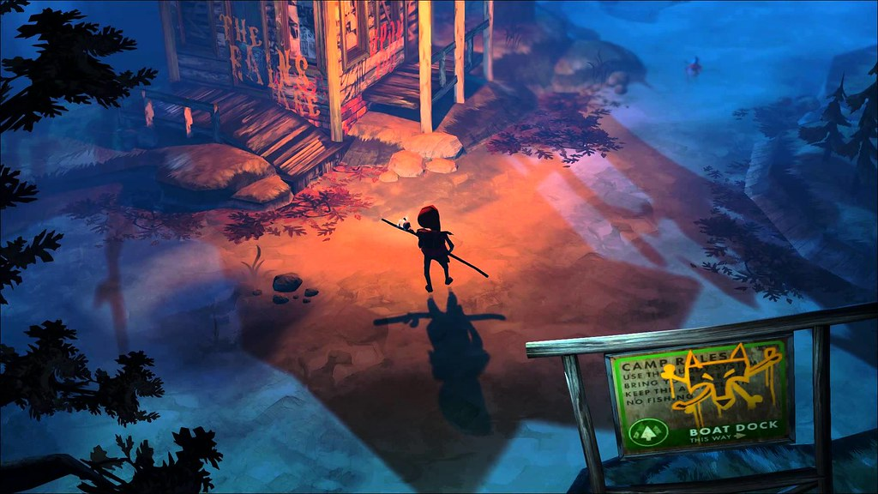

[**click here to learn more about AAA games.**](https://geekygamingstuff.com/what-are-aaa-games/)

Alas, I did not tell them that, and I regret it, so to make amends, I have come up with a "happy compromise." I started making a text-based "game" using HTML and CSS. It's basically like making the LaCroix sparkling flavored water of video games. In my game, instead of using a controller, you will use a mouse click. Instead of having graphics, you have text written in the "choose your own adventure book" type format. I don't use Unity, Blender, or C#, among other things (although sometimes I wish I did). Instead, I  make simple, static web pages that only use HTML and CSS. I don't even use Javascript! (that's what you use to make more fancy dynamic web pages).

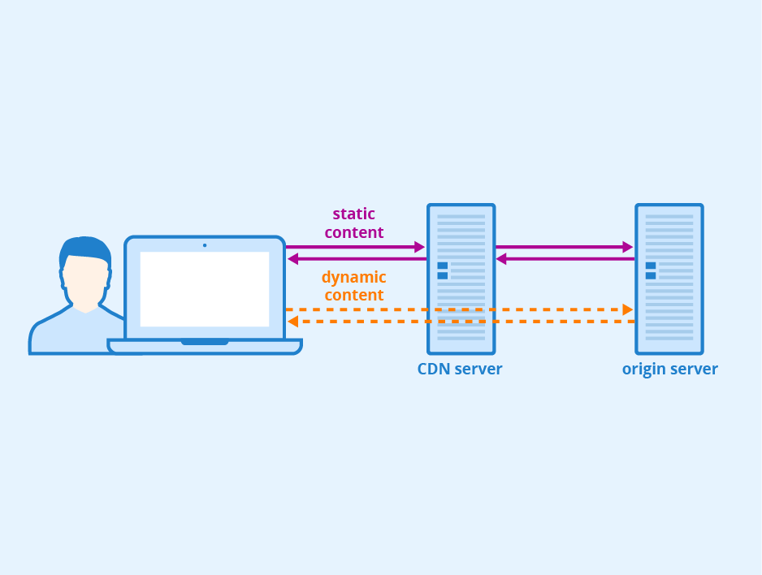

[**click here to learn more about Static vs. Dynamic webpages**](https://wpamelia.com/static-vs-dynamic-website/#:~:text=Static%20websites%20are%20ones%20that,databases%20in%20addition%20to%20HTML).

Now I feel your mind yelling, that sounds boring! Making the next Cuphead sound much more fun, do that instead! To your mind, I must retort; please calm down!  Everyone, including the people who made Cuphead, has to start somewhere. Besides, the key to being able to do anything well is practice. So I say let's practice with simple, static, story-heavy web pages.  I mean, all the graphics in the world are not going to make a bad story good (though they can make a bad story look cool).  Creating text Html games allows me to learn some code and focus on great storytelling via creative writing at the same time. It sounds like a win-win to me, and if that also sounds like a win-win to you, I invite you to start an expedition into HTML and CSS  with me. Which, by the way, I will now refer to as the Dino-pedition, it makes sense, trust me. So the goal is to create a "game." To achieve that goal, we need to start by creating a story that is driven by:

1. our characters.
2. a world for our characters to interact with.
3. our characters' decisions inside our world.
4. and how those decisions will inform our characters' fate.

We also need to code all of that. That sounds like a lot already. I bet right about now that that boring static web page looks a lot easier to pull off than The Next Cuphead.

Just a little reminder from our last [**Blog**](https://www.richlandlibrary.com/blog/2021-06-23/htmlcss-expedition-dinosaurs)...

So the goal is to create a "game." To achieve that goal, we need to start by creating a story that is driven by:

1. Our characters.
2. A world for our characters to interact with.
3. Our characters' decisions inside our world.
4. And how those decisions will inform our characters' fate.

Now that the expedition has started the number one thing we need to do, make characters. When making characters, sometimes it's great to create someone new out of thin air. Though it can be a lot of fun and very exciting, it can also be challenging. So more times than some, I tend to lean more towards embellished borrowing. An imitation is a superb form of flattery, right? So to make our characters and begin creating our, I leaned into some unexpected inspiration—Children's Picture Books.



 I know what you are thinking. Jessica C., you are an adult. Why are you reading children's picture books? To your brain, I will counter with the following: I am reading children's books because they are a twofer (pronounced: two-fur). For the uninitiated, a twofer is a two-for-one. With children's books, the one is fantastic and quirky art. The two is the fact that children's books tend to be quick and easy reads. That quick and easy read has the bonus of having a story that can develop a whole character with a backstory in less than 30 pages. So technically, that would make them a threefer. Before you let the upside of reading children's books hook you, there is a downside. That being, there are a LOT of children's books to choose from, sometimes making it daunting to pick just one.

Lucky for us Richland Library provides a great resource to help us that's free ninety-nine! Enter Novelist Plus and Novelist K-8!

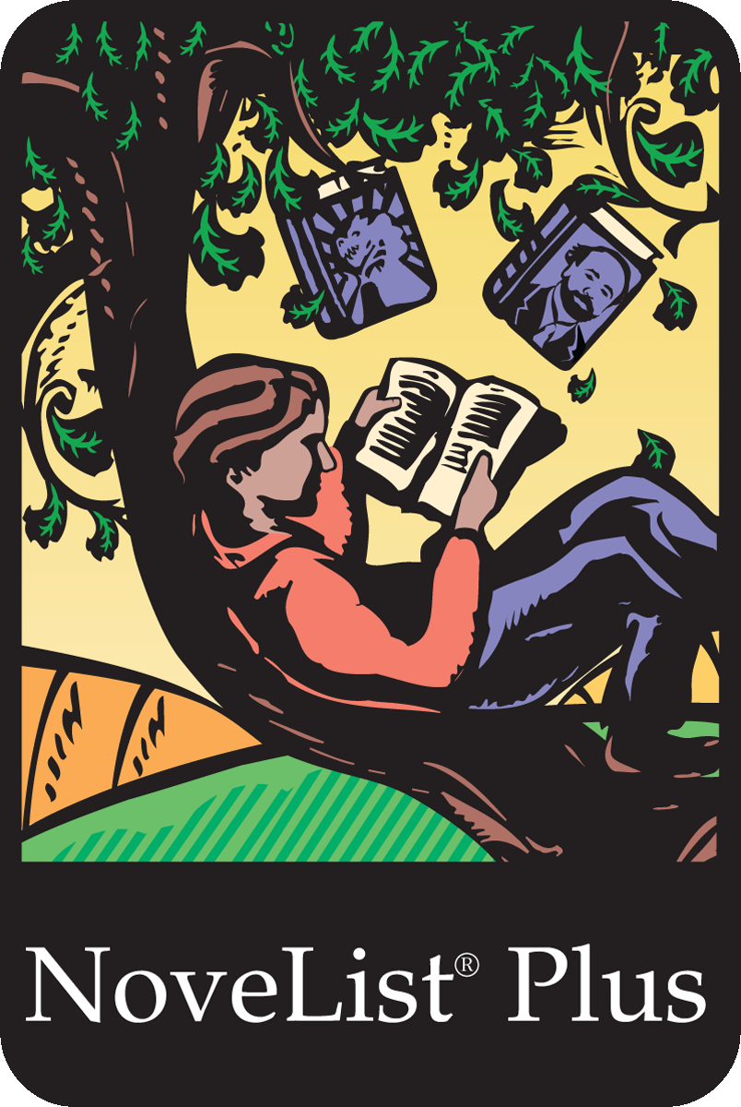

 If you go to richlandlibrary.com, click on research and learn, scroll down to the reading category and then look around, you should see NoveList k-8 puls as well as NoveList Plus. You can also just click [**HERE**](https://www.richlandlibrary.com/research-learn/all?subjects%5b69%5d=69&search=). NoveList will give you reading suggestions, plus is for all books k-8 well books from kindergarten to eighth grade. Once you are on the NoveList site, you can search for everything. You can narrow things down by the author, the subject, audience age, whatever you want. My favorite part about NoveList is that if you click on a book to check it out, a list of similar books will show up on the right side of the screen! I enjoy just going down the recommended similar books rabbit hole. Other than NoveList, I have a few more tactics. One such tactic is visiting a location and walking around looking at all the children's books out on display. Librarians just prop them on the tops of the shelves for you to enjoy. Sometimes I walk through the stacks of shelves looking at the spines of books. If I see one with an exciting title, I will pull it off the shelf. If the art looks cool, I'll give it a read.

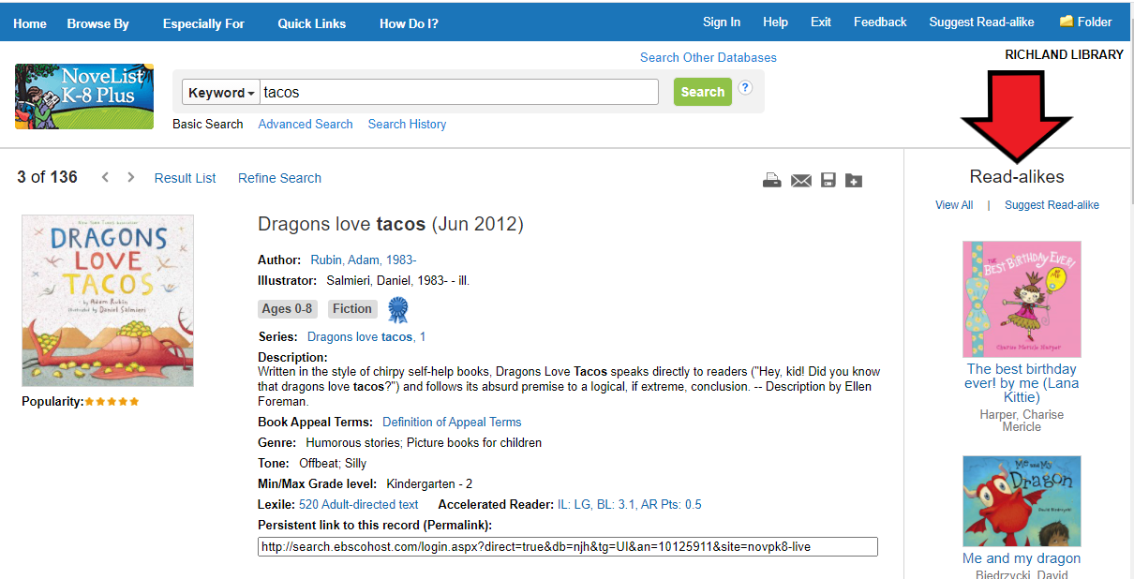

I employed all the aforementioned tactics when I thought about creating this game, and I ended up with a nice stack of books:

#### Ada Twist, Scientist by Andrea Beaty, illustrated by David Roberts

#### If I Had a Raptor by George O'Connor

#### We don't eat our classmates by Ryan T. Higgins

#### Dragons love tacos by Adam Rubin

#### Dragons love tacos 2: the sequel also by Adam Rubin

#### The super hungry dinosaur by Martin Waddell, illustrated by Leonie Lord

#### Tiny T. Rex and the Impossible Hug by Jonathan Stutzman, illustrated by Jay Fleck

Once you find some books you like, keep a note of the authors and or illustrators. The next time you search, you can use NoveList to suggest similar books for both the authors and the illustrators on your list! Once you have a good list going, start searching the library website for them, you can put them on hold or write down the call numbers and go and pick them from the shelves. Some may be available digitally on Overdrive or Hoopla. Some may even have a video version of the book. If you come across a book we don't have, you can (insert link here) request that we purchase it.

Once you have your books, please read them, then re-read them. At that point, you should be ready to decide who your characters will be. After I read my stack of books, I decided that I wanted my characters to be. Penelope, the T.Rex from we don't eat our classmates, the Hungry T.Rex from the super hungry dinosaur, whom I'm calling Hank Ree (get it, no?). Tiny, the T.Rex from Tiny T.Rex, and the impossible Hug. And finally, the female raptor from If I had a raptor, I named her Rogue, after my cat. After deciding that Penelope, Hank Ree, Tiny, and Rouge would be my playable characters. I read the books one more time to make a shortlist of qualities that they had. Here is what I came up with:

**Penelope:**

* **Scarred of goldfish as she knows they think dinos are delicious**
* **Introduced to human children in the 1st grade**
* **She gets along with human children (now) but still thinks they are tasty**
* **thinks the number of teeth you have is important**
* **Feels that ponies are also delicious**
* **Likes apple juice**
* **Knows first hand how hard it is to make friends**

**Hank Ree:**

* **When he is super hungry, he prefers to eat people and/or their pets**
* **When he is super hungry, he will cause property damage**
* **Vulnerable to being tied up, and if in that state for a while, he will cry and follow any commands to be untied**
* **Loves meals prepared by his human friend Hals mom**
* **When super full, prefers to stay away from humans and their pets**

**Tiny:**

* **His best friend is a Stegosaurus named Ponty**
* **His Dad is a Scientist**
* **His Aunt Junip is a Yogi who enjoys cucumber juice**
* **He lives in a house with his parents, Aunt, and Sister, and Brother**
* **His Mom is lovely**
* **His Brother and Sister, Lawrie and Trixie, are athletic and enjoy ping pong**
* **He is good at planning, training, and practicing**
* **He always tries his hardest**
* **He likes to keep the people closest to him happy**

**Rogue:**

* **She grew up as a humans pet**
* **She was fluffy, funny, and cute as a baby**
* **She is quiet and good at hiding**
* **She likes to sit in her human's lap**
* **She wants to be in cozy warm spots**
* **She sleeps a lot during the day and runs around at night**
* **She can see in the dark**
* **She will be sure to let you know if she is hungry**
* **Her claws need clippings regularly**
* **She enjoys stalking "prey" (even if the prey is not a real thing)**
* **Raptors, in general, are very remarkable, but Rouge is the most noteworthy raptor ever**

Just a little reminder from our first [**Blog**](https://www.richlandlibrary.com/blog/2021-06-23/htmlcss-expedition-dinosaurs)...

So the goal is to create a "game." To achieve that goal, we need to start by creating a story that is driven by:

1. [**Our characters**](https://www.richlandlibrary.com/blog/2021-06-24/pt2).
2. A world for our characters to interact with.
3. Our characters' decisions inside our world.
4. And how those decisions will inform our characters' fate.

Now that we have finished Number 1 let's move on to number 2, creating a world for our characters to interact with. For me, the world had to revolve around my character's reason for being there in the first place. I had to give my characters a mission. I decided to mainly just elaborate on top of the area that the dragons inside the book lived. All the specifics that you don't get from the story I got to make up. This world will now be known as DLT World, aka D-dragons L-love T-tacos world. As far as the mission goes, I originally wanted to focus on discovering the origins of why dragons love tacos so much. So initially, the mission was that the dinosaurs needed to find out why dragons love tacos, and who better to help than Ada Twist, Scientist!

To start the mission, I had to get the dinosaurs to DLT world. How would I do that? Then it hit me, "the Kid" could summon them! You know that Kid who throws all the best taco parties. I decided that he sent out party invitations to all the dinosaurs involved for some reason. Then I started writing. Well, I tried to start writing. I realized that I didn't know anything about DLT, so I started making a list of what I knew based on what the pictures and text in Dragons love tacos and Dragons love tacos 2 told me.

### There are mountains with snow caps.

### There are taco caves.(stores)

### Everything seems gray and flat.

### There are brown "fields?" for parties with instruments and dancing.

### There is at least one beach with a few coconut trees.

### I saw short gray trees with leaves pointing down (like Christmas trees) and tall skinny trees with leaves pointing up. (like reverse Christmas trees)

### There is a boat on land by the Kid and his dog's house. The Kid fills the boat with tacos during parties.

### The Kid could buy boxes of supplies for tacos (tomatoes, lettuces, cheese, beef, and chicken). Where did they come from? Perhaps a taco cave store?

### When the taco shortage came, the Kid came through with a time machine.

### Using the time machine, the Kid discovered that tacos could be planted to create taco trees.

### This world has a newspaper.

### Taco scientist are a thing in this world.

Using that list, I made a new list of things I decided would be true about the DLT world.

### If you live in the DLT world, you most likely work in the taco industry. The taco industry is the leading supplier of jobs in the DLT world. There are other industries, but it's a taco town.

### All the DLT worlds taco supplies are insourced except for the salsa. Citizens of the DLT world have attempted to make salsa, but it's never as good as what they import. The DLT insourced salsa is so bad the Citizens of the DLT world even started a fantastic festival every three years to celebrate their lousy salsa. It's like a chili cookoff where teams and individuals sign up to try their hand at their best salsa recipe. At the end of the cooking stage and right before judging, the judges unveil a giant custom glass salsa jar they made for this reason only. The jar is there to hold gallons of imported salsa. Everyone eats tacos with the imported salsa, and they dump all the DLT salsa into a giant salsa "fertilizer" pit (in the DLT world, unlike the real world, salsa can be fertilized).

### Taco cave is the leading exporter of taco supplies and pre-assembled tacos.

### Perhaps the taco cave becomes the leading farm industry of taco trees after the Kid discovers that you can plant tacos. the Kid and his dog are trailblazers

### Taco cave also supports taco research and trains taco scientists to work out the kinks that pop up in the taco crops industry.

### The primary forms of entertainment in the DLT world are parties. Parties in the fields, dance parties at the beach, costume parties, pool parties, big gigantic parties with accordions, and tiny little parties with charades. Citizens of the DLT world love parties for the conversation, the dancing, the comforting sound of a good friend's laughter, and so much more. They especially love taco parties as they combine the two things the dragons love best, parties and tacos. Parties at the Kid's house are the best. He throws the best parties in general and the best taco parties expressly. Every citizen of the DLT is always trying to get invited to one of the Kid's parties.

### The DLT world is gray and flat. There is a distant mountain range with all the mountains have snowy peaks. Following the mountains is a forest of tall trees whose leaves point skyward. Intersecting the forest is a river that flows thru the DLT world. The trees inside of the DLT world are short and look like Christmas trees. There is also a scattering of coconut trees on the beach, but dragons don't like coconuts.

### The dragons found out (after the fact and due primarily to Ada Twist and the Dinosaurs) that the taco crops were decimated due to sabotage and spicy salsa. Taco trees don't like spicy salsa either.

Now we can write a story. You can use old fashion pencils and paper, but I like typing. Now when most people think of typing on a computer, they think of Microsoft Word. Pro Ms. Jessica Tip: I like using Notepad instead of Word at first. Notepad does not bother with formatting or spelling, making it a good way for me to get my ideas out quickly without worrying about extra stuff. I also like to write myself notes during my draft. If I write something I want to come back to, or I don't know what to say at the moment but want to keep going, I just make a note.

>>No clue what to say here maybe I'll figure it out<<

Then I just keep writing. If you come to a part of your story where you get stuck or don't know what to do, just write yourself a note and keep writing. If all else fails, just pull something out of the air and write it down. When I first started writing my story, I had no clue where to start, So I started with a note about not knowing where to start.

>> IDK how to start. How do these dinos know each other?! Where do I start this story?! Perhaps Penelope and Hank Ree know each other from an internet chat room group for hungry dinos who used to like eating ppl the most, but they have changed their ways due to whatever reason. Like AA but for ppl eating dinos. I want to say that tiny started taking care of rogue when her owner (died?), but IDK. He's so young in the story, and I feel she may be older than him. Maybe they are in a chatroom for dinos who like to hug/be hugged? Maybe Penelope and rogue get the invite and make Hank and Tiny their plus-ones? Yeah, let's go with that! Then again, where do we start this story? Like at the party? If so, from whose perspective? AHHHHHHHHH! <<<

I took a vacation after that, not a tropical vacation, just a few days where I didn't look at the story. When I came back to it, I wondered what Tiny's life was like and started writing that. Before I knew it, I had a backstory for him and how he got invited to the party. Then I knew how the Dinos would all meet at the party, and I wrote that down.

Initially, I wanted the story's main goal to be the Dinos searching to find out why dragons love tacos. But as my writing progressed, things changed. I kept coming up with new questions. For example, the Kid who throws the best taco parties would know better than to buy spicy salsa, so where did it come from? Maybe the dinos don't get a chance to try a taco before the house burns down. Perhaps that is their motivation for solving the totally mild spicy salsa mystery. It wasn't my original idea, but I liked it, and I ran with it. If you want to read my finished story, check out my Dinos, Dragons & Tacos "novella." I hope it can provide you with some inspiration.

 Now get writing!